UNIVERSIDAD EUROPEA DE MADRID
FLUID MECHANICS II
HOMEWORK 7

Problem 1
Water flows in a pipe of 100m long and 1cm in diameter. The measured average velocity is 2m/s, The water temperature is 10°C. Determine the pressure drop for a given velocity. Calculate the pumping energy to overcome the pressure drop. If the velocity is decreased to 0,2m/s. Repeat the calculations

Problem 2
A pipeline 10m long transport water at 25°C. The diameter of the pipe is 0,2m. Assume turbulent flow, determine the flow rate if the pressure drop is 200KPa. Validate the assumption of turbulent flow.

Problem 3
Determine the pipe diameter if the pipe length is 200m, the velocity is 2m/s and pressure drop is 2500KPa.

Problem 4
A parallel pipes as shown in below figure. The diameter of one pipe is 0.5m and is 1000m long. The other pipe has an internal diameter of 1m and is 1500m long. Both pipes are made of cast iron (ε= 0.26 mm). The water is transported by the system of pipe, the temperature of water is 20C The total flow rate is 4 m3/s. Find the flow rate in each pipe and the pressure drop in the system. There is no elevation change. Neglect minor losses
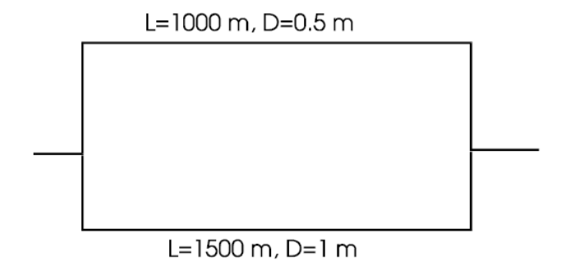
Problem 5
The below figure shows the system of pipe connected in series, and the measure of the pressure drop is 200 kPa. The elevation of the system is 10m. For calculations consider the temperature of Water at 20C. For this system of pipe determine the volume flow rate.
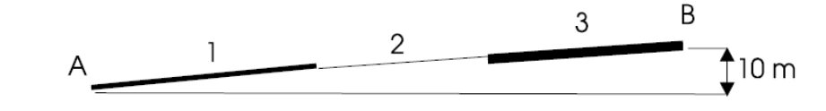
Characteristic of pipes are the following
Pipe Length (m) Diameter (m) Roughness(mm) Relative roughness
1 100 0.1 0.25 0.0025
2 50 0.08 0.10 0.00125
3 120 0.15 0.2 0.0013

Problem 6
The piping system is shown in below figure. What horsepower can be extracted from the turbine when the volume flow rate is 0.16ft3/s, the temperature is water at 20°C and the pump head is 60ft? All pipes are made of cast iron.
